Horse Identification and Passports: Brief Guidance for Horse Owners

Ensure your horses passport is updated with all vaccinations (and medications if Section II part II is signed)
Update Records
Microchip Implanted by Vet

Owners must sign section II part II of the passport if you do not wish for your horse to enter the food chain – this is an irreversible decision 'intended for human consumption'

Before you apply for a passport, you must ensure your horse is implanted with a microchip by a qualified veterinarian
Return your passport to the PIO to update if ownership details change.

Return passport on the death of your horse
Sign Section II
Apply for Passport

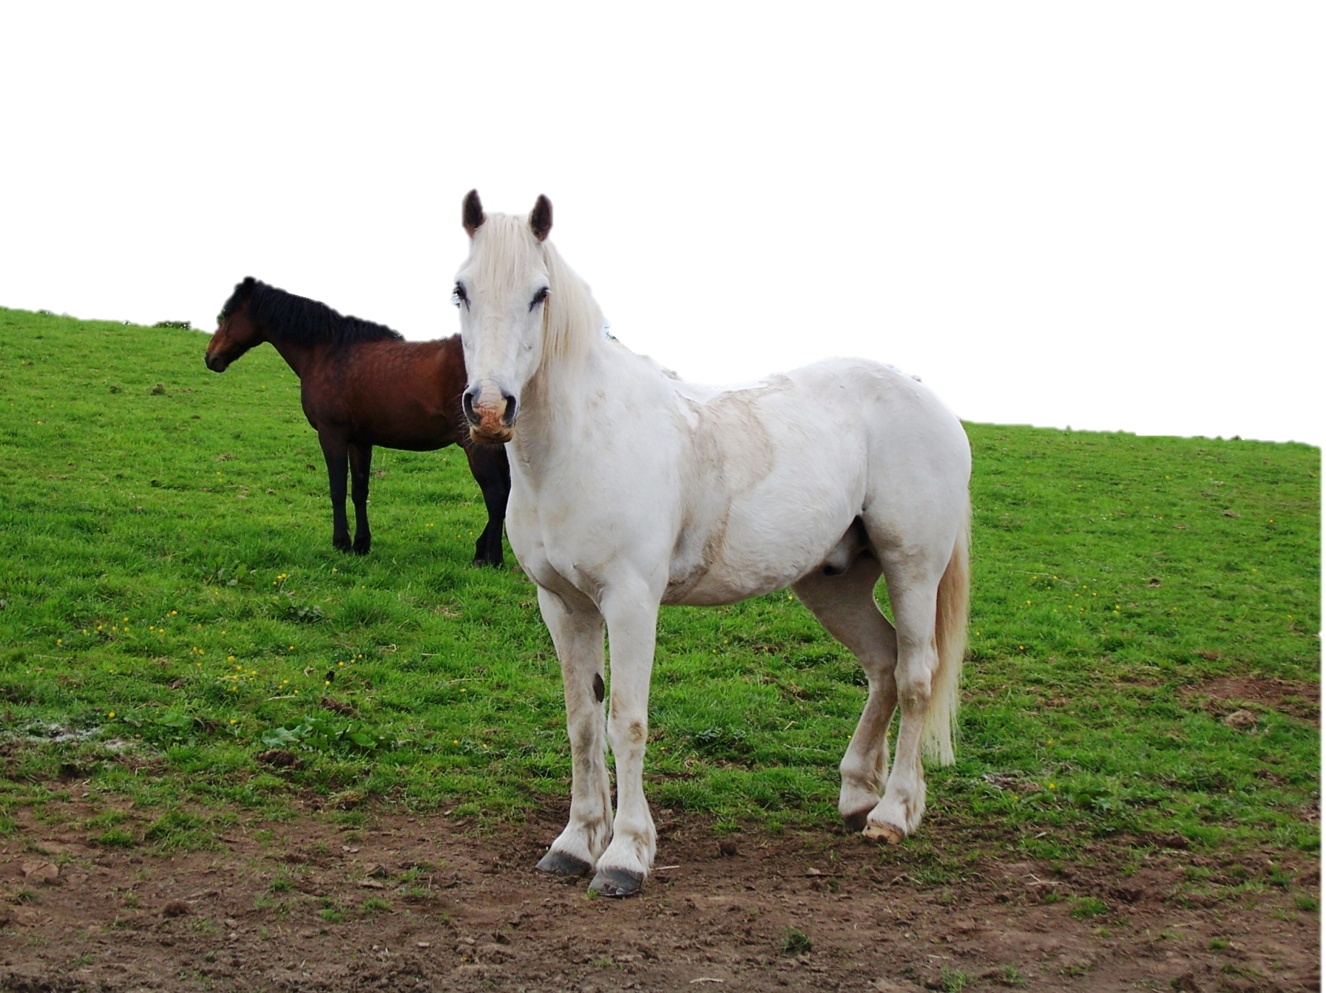
Request an application pack from the Passport Issuing Organisation (PIO) (Most organisations allow you to do this online)
Complete application pack and return it to the PIO
They will then send you your horse's passport, which is valid for your horse's lifetime
PIO's will then update their records and can return the passport to you on request
In the event of the death of your horse, you should return your horses passport to the PIO who issued it
Passports for young horses (foals) must be obtained no later than 31 December in the year of birth or by six months after birth, whichever date is later.

