THE CLYDESDALE HORSE SOCIETY WINTER FAIR

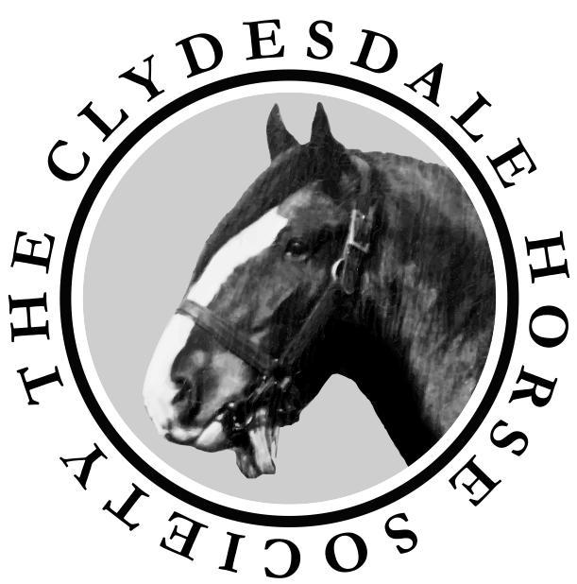

www.clydesdalehorsesociety.com

LANARK AGRICULTURAL CENTRE

SATURDAY 18th NOVEMBER 2017

Judge: Mr Ian Johnston Kirkton Farm, Bothkennar, Falkirk
Judging commences at 10.45am

President: Mr Peter Keron
Vice President: Mr James Rochead
Immediate: Past President: Mr Ian Craig
Hon Treasurer: Captain James Anderson

Secretary: Ian A Roy BA
7 Turretbank Place, Crieff, PH7 4LS
Tel: 07720 895870.

Email: secretary@ clydesdalehorsesociety.com

Kindly supported by the legacy of
the late Gerald Fallowes

Schedule of Classes

- Novice Handler – for those aged over 16 to be judged on handler’s performance only, horse used must be entered in an in-hand class.
- Gelding born in or before 2014.
- Mare or filly born in or before 2014.
- Filly born in 2015.
- Colt or gelding born in 2015 or 2016.
- Filly born in 2016.
- Senior colt foal born on or before 30/4/2017.
- Senior filly foal born on or before 30/4/2017.
- Junior colt foal born on or after 1/5/2017.
- Junior filly foal born on or after 1/5/2017.
- Pair of foals by the same sire - entry on the day.
- Young Handlers Class for those aged 12 – 16 on the day of the Show (run under CHS rules). Qualifier for Young Handler Final 2018.

Entry Fees
Class 1 - no fee
Classes 2 to 10 - £10 per entry
Classes 11 and 12 - no fee

Prize money
Overall Champion - £100
Reserve Overall Champion - £50

Classes 2 – 10
1st £50
2nd £40
3rd £30
4th £20
5th £15
6th £10

Class 12
CHS rosettes and a memento to all competitors

Rosettes to 6th place in all classes

Judging to start at 10.45 am with the novice handler class.
Class 2 will not commence before 11 am
Trophies

Peter Sharp Perpetual Challenge Trophy
Overall Champion

Clydesdale Horse Society Shield
Reserve Champion

The Paul L Cooper Perpetual Challenge Trophy
Best Foal

The George Robertson Trophy
Best Foal Bred by Exhibitor

The Kildean Perpetual Challenge Trophy
Best Animal Bred by Exhibitor

The Jackton Trophy
Best Senior Horse

The Macfin Perpetual Silver Salver
Best Horse of opposite sex to the Overall Champion

The Manuel Trophy
Best One or Two Year Old

The Auchengree Clydesdales Trophy
Presented by Matthew Burks and Jacqueline Pettigrew
Best Young Handler

Rules and Regulations for the Clydesdale Horse Society Winter Fair

Disclaimer of Liability to Exhibitors
- The Clydesdale Horse Society shall disclaim liability for the death or personal injury caused by the negligence of the Society, its servants or agents, or any person whilst entering or leaving the Showground. The Society shall not be responsible for death, injury, disease or loss caused to any exhibitor or by any vehicle brought by the exhibitor to the showground or car park. Acceptance of the foregoing is a condition of entry. Exhibitors are advised to insure against fire and other appropriate risk as regards their own property and against third party claims.

Entries
- Entry fees are as stated. The correct fee must be remitted with the entry form or entries will not be accepted. No refunds will be given.
- The Society reserves the right to refuse entry and return the entry fee to any person.
- Horses exhibited must be owned by the named exhibitor at the date of closure of entries and the entry form must be signed by that owner/exhibitor. All owners/exhibitors must be current members of The Clydesdale Horse Society. All mares, fillies and stallions must be registered or be in the process of being registered with The Clydesdale Horse Society at the entries closing date. Colts and geldings must be entered as Produce or be in the process of being entered as Produce with the Society. Horses entered in the Grade-Up Appendix, Colts out of a Grade-Up mare or horses of unknown pedigree are not eligible to compete.
- Exhibitors are solely responsible for the accuracy and eligibility of their entries. Exhibitors must prove the correctness of their entries if required to do so by stewards.

Protests
- All protests must be made in writing to the Secretary of the Society before 4pm on the day of the Show. This must be accompanied with a £50 deposit which will be returned if the protest is upheld. The protest will be considered by the Executive Committee of the Clydesdale Horse Society in consultation with stewards.

Disqualification
- The Chief Steward has the power to disqualify any entry. There is no appeal against any disqualification made by the Chief Steward or by the Judge.

Mode of Dress
- Handlers should wear a shirt and Clydesdale Horse Society tie. White coats MUST be worn in the ring.

Number of Attendants in the Ring
- Only two persons will be permitted in the ring with each horse, namely the person leading the horse and one attendant for dressing out purposes.

